## **Objective**

This document outlines the steps for workspace setup for HBUS E2 Staff Front End – portal Workspace Setup

* Copy new maven to your C drive (keep back up of current maven) from this location \\161.84.113.59\greenfield\rajesh
* Add your system username/password to C:\apache-maven-2.2.1\conf\settings.xml

## Software Installation & Configuration

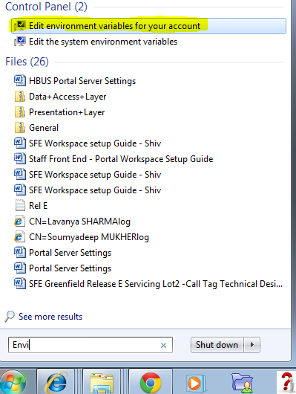

### JAVA Configuration

#### Create JAVA_HOME = <C:\Program Files\IBM>\SDP\jdk

JAVA_HOME is a location where the JDK is installed on your computer.

#### Update PATH = %JAVA_HOME%\bin;

PATH system variable has to be updated to include the java binary into the system path.

### MAVEN Configuration

#### Create M2_HOME = C:\apache-maven-2.2.1

M2_HOME is a location where the MAVEN is installed on your computer.

#### Create MAVEN_OPTS = -Xmx1024m -XX:MaxPermSize=128m

#### Update PATH = %M2_HOME%\bin;

PATH system variable has to be updated to include the MAVEN binary into the system path.

**Run the following command to install current certificate:**

"%JAVA_HOME%\bin\"keytool -import -trustcacerts -noprompt -alias hsbc_root_ca -file \\hbeu.adroot.hsbc\dfsroot\GB002\DS_BUILD\GBM\HSBC_Root_CA\HSBC_Root_CA.crt -keystore "%JAVA_HOME%\jre\lib\security\cacerts" -storepass changeit

### Eclipse Configuration

#### Install and Configure Maven plugin

For Installation,

Go to Help > Install New Software

Enter m2eclipse plugin URL:

<http://cmst01.global.hsbc:90/repos/software/eclipse/update-site-rad8/site.xml>

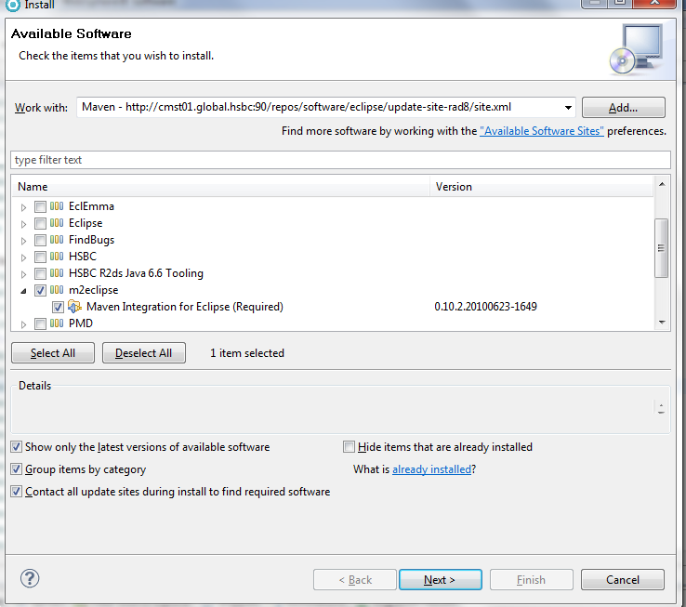

Check if you have RTC installed under

C:\SWDTOOLS\IBM

Go to RAD -> Help -> Install new Softwares

http://tools-software-development.it.global.hsbc/repos/software/eclipse/update-site-rad8



For Configuration,

Go to Windows -> Preferences -> Maven -> Installations

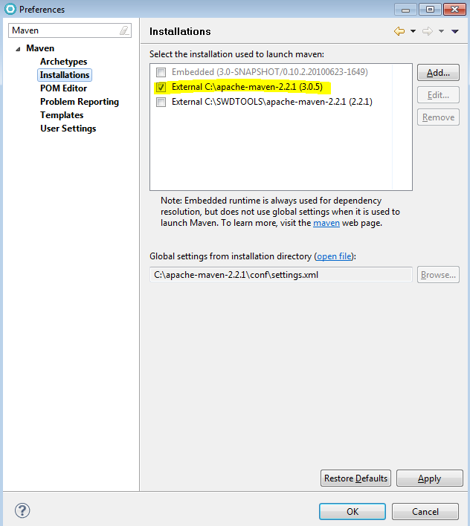

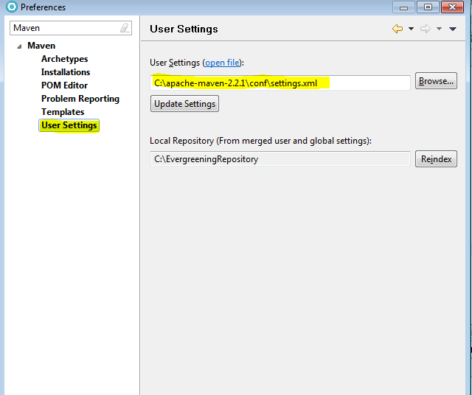

## Sandbox setup

Open Eclipse

Eclipse - File - Accept Invitation -

teamRepository=https://jtsrv.uk.hibm.hsbc:9094/jazz/

userId=43884393

userName=Shivshankar Awari

projectAreaName=group.channels.staff

teamAreaPath=/Core Engineering/Core Team/Activation Core Reference

### Downloading streams in RTC

Then Open the Team Artifact from

Eclipse- Windows -Show Views - Others - Search for Team Artifact

Eclipse - Team Artifact - Open Source code

On the “Team Artifacts” view, under the group.channels.staff repository

Expand the “Source Control” folder

Look for the **SFE 2.0 FS1 PORTAL ACTIVATION STREAM**

Right-click New, then click on “Repository Workspace”

C:\sandbox\fs1portalactivation

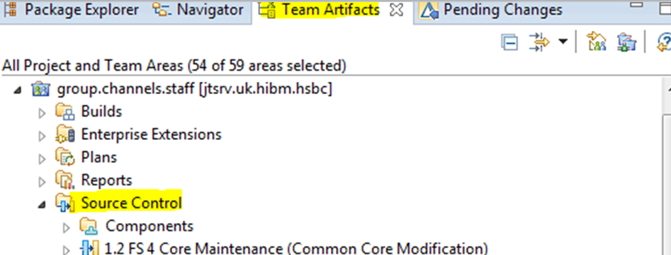

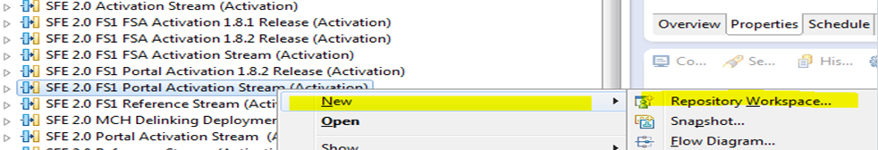

* Click “Next” thrice.
* Make sure to select ALL components and check the “Load Repository workspace after creation”. (Refer to the image below).
* Then, click “Finish”.
* On the “Load Repository Workspace” window. Select “Find and load Eclipse projects”

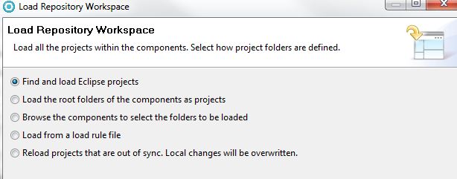

* Click “Next”. Select the entire project, and then click “Finish”.

### Building Projects through Maven

* Open cmd prompt
* Go to C:\sandbox\fs1portalactivation\group-staff-buildaggregate
  + Mvn -e clean install
* without compiling the Junit tests
  + Mvn -e clean install -DskipTests

Eclipse - Team Artifact - Open Source code

Look for the **HBUS Rel E Integration FS4**

Right-click New, then click on “Repository Workspace”

C:\sandbox\hbusreleintegration



### Building Projects through Maven

* Open cmd prompt
* Go to C:\sandbox\hbusreleintegration\htsn-staff-buildaggregate
  + Mvn -e clean install
* without compiling the Junit tests
  + Mvn -e clean install -DskipTests

#### **Build Configuration**

Disable “Build Automatically” feature in RAD

Go To Project -> Unselect “Build Automatically”

### 

### Building Projects through Maven

* Open cmd prompt
* Go to <workspace>\group-staff-buildaggregate
  + Mvn -e clean install

The above command will build the entire staff front end.

* After a successful first build, subsequent builds can be speeded up by building in offline mode and without compiling the Junit tests
  + Mvn -e clean install -DskipTests

## **WebSphere Application Server Configuration**

There is a WebSphere Application server embedded in WebSphere Portal server install.

* Before hitting URL open command prompt goto this location according to your machine C:\SWDTOOLS\IBM\wps70was70\wp_profile\bin and run this command

**startServer.bat WebSphere_Portal** and for stopping server **stopServer.bat WebSphere_Portal**

* Access it from Web Browser

URL: https://<host>:<port>/ibm/console/logon.jsp

Sample: https://localhost:10032/ibm/console/logon.jsp, [http://localhost:10032/ibm/console](http://localhost:10042/ibm/console)

* Application server usually runs on port 10032 (HTTPS) or 10042 (HTTP) by default.

<https://localhost:10039/wps/portal/>

### Go to WAS Application Servers ->Server1 - >Process Defination -> Java Virtual Machine

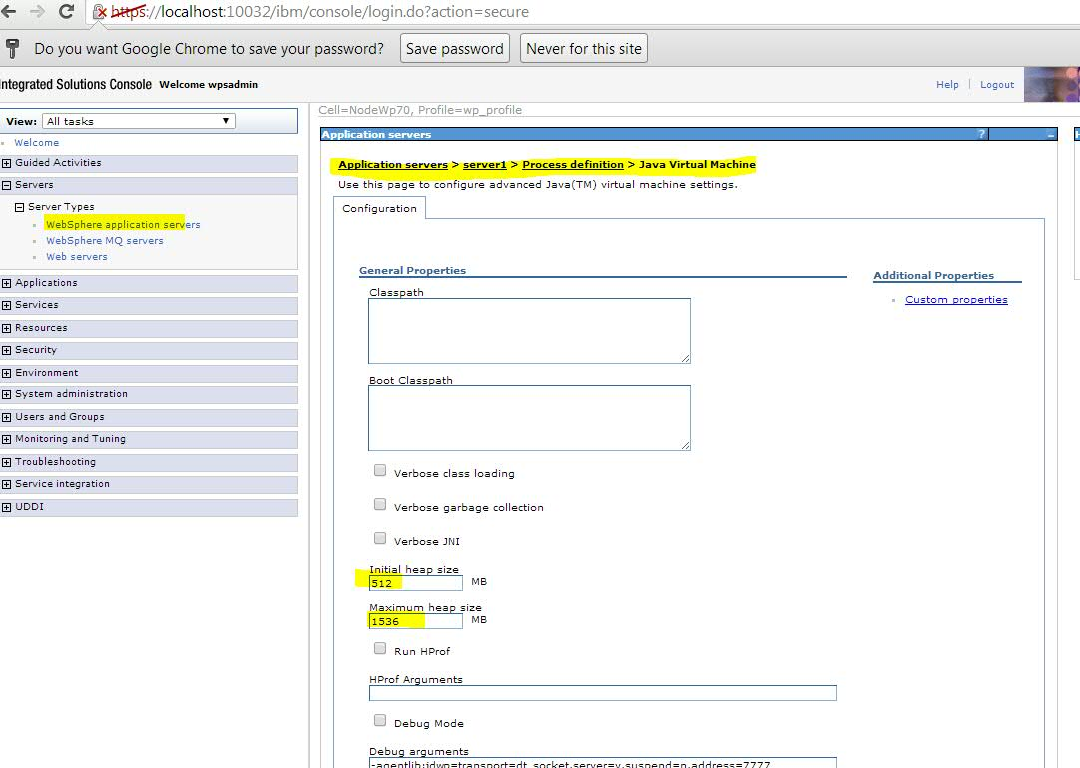

### Go to WAS admin console ->Security - Global security

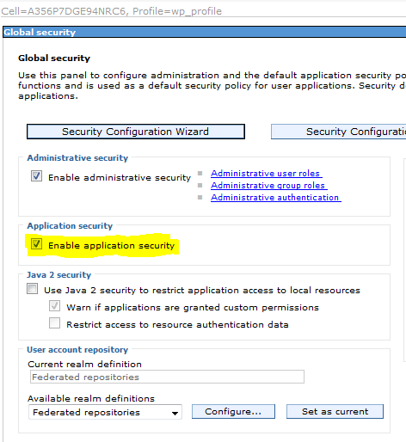

### Namespace Binding (JNDI Settings)

Go to WAS admin console -> Environment -> Naming -> Name space binding

|  |  |  |
| --- | --- | --- |
| **Name** | **nameInNameSpace** | **stringToBind** |
| LOG_ROOT | HSBC/OHD/LOG_ROOT | C:/logs |
| HSBC/STAFF/LOG_ROOT | HSBC/STAFF/LOG_ROOT | C:/logs |
| HSBC/OHD/DEFAULT_CHANNEL_SITE_CODE | HSBC/OHD/DEFAULT_CHANNEL_SITE_CODE | 400 |
| HSBC/STAFF/CRMS/OPPORTUNITYMGMT/IMPL | HSBC/STAFF/CRMS/OPPORTUNITYMGMT/IMPL | hostAdapter |
| HSBC/STAFF/REFERENCEDATA/IMPL | HSBC/STAFF/REFERENCEDATA/IMPL | hostAdapter |
| HSBC/STAFF/AO/CUSTOMERINFORMATION/IMPL | HSBC/STAFF/AO/CUSTOMERINFORMATION/IMPL | hostAdapter |
| /HSBC/CA/PROXYTHEME/CACHE_REFRESH_ENABLED | /HSBC/CA/PROXYTHEME/CACHE_REFRESH_ENABLED | true |
| /HSBC/CA/PROXYTHEME/CUN | /HSBC/CA/PROXYTHEME/CUN | hsbc.theme.esf-ca-app-proxy-theme |
| /HSBC/CA/PROXYTHEME/FALLBACK_ENABLED | /HSBC/CA/PROXYTHEME/FALLBACK_ENABLED | True |
| HSBC/STAFF/SESSMGMT/IMPL | HSBC/STAFF/SESSMGMT/IMPL | hostAdapter |
| HSBC/STAFF/CUSTENQ/IMPL | HSBC/STAFF/CUSTENQ/IMPL | hostAdapter |
| HSBC/STAFF/WAS_UID_NAME | HSBC/STAFF/WAS_UID_NAME | Logs |
| OHD_CONFIG_LOCATION | HSBC/OHD/CONFIG_LOCATION | C:\swdtools\BM\WebSphere\PortalServer\shared\app\group **(Please edit this path as per your system)** |
| STATEMANAGEMENT_CONFIG_LOCATION | STATEMANAGEMENT_CONFIG_LOCATION | C:\swdtools\BM\WebSphere\PortalServer\shared\app\group\group\statemanagement **(Please edit this path as per your system)** |
| HSBC/STAFF/CHNLSVC/CHNLSVC_URL | HSBC/STAFF/CHNLSVC/CHNLSVC_URL | <http://cd498.p2g.netd2.hk.hsbc/>" |
| HSBC/STAFF/BUSSVC/BUSSVC_URL | HSBC/STAFF/BUSSVC/BUSSVC_URL | <http://cd498.p2g.netd2.hk.hsbc/> |
| HSBC/STAFF/ASSISTED_URL | HSBC/STAFF/ASSISTED_URL | http://localhost:10039 |
| HSBC/OHD/ADAM/PASSWORD | HSBC/OHD/ADAM/PASSWORD | /QpImjzpCOGNrvvJVpNXrN0AFRcMG2uN |
| HSBC/OHD/ADAM/DECRYPTION_KEY | HSBC/OHD/ADAM/DECRYPTION_KEY | ebb9f5b4b76a3de3e929c7ff0ccbd396 |
| HSBC/OHD/ADAM/BASE | HSBC/OHD/ADAM/BASE | DC=InfoDir,DC=Dev,DC=HSBC |
| HSBC/OHD/ADAM/USERDN | HSBC/OHD/ADAM/USERDN | CN=InfoDir-HNAH-OHD,OU=Service Accounts,DC=InfoDir,DC=Dev,DC=HSBC |
| HSBC/OHD/ADAM/URL | HSBC/OHD/ADAM/URL | ldap://gluetest.systems.hk.hsbc:3268 |
| HSBC/OHD/ADAM/PWD_ENCRYPTION_ALGORITHM | HSBC/OHD/ADAM/PWD_ENCRYPTION_ALGORITHM | PBEWithMD5AndDES |
| HSBC/STAFF/CHNLSVC/CHNLSVC_ENCRYPTIONKEY | HSBC/STAFF/CHNLSVC/CHNLSVC_ENCRYPTIONKEY | Fsastaffkey |
| HSBC/STAFF/FSA_URL | HSBC/STAFF/FSA_URL | <http://localhost:10039> |
| **CHNLSVC_URL** | **HSBC/STAFF/CHNLSVC/CHNLSVC_URL** | **http://localhost:9081** |
| **BUSSVC_URL** | **HSBC/STAFF/BUSSVC/BUSSVC_URL** | [**http://localhost:9081**](http://localhost:9081) |
| HSBC/STAFF/CRMS/TRANSPORT | HSBC/STAFF/CRMS/TRANSPORT | jndiMqTransport |
| HSBC/STAFF/REFERENCEDATA/TRANSPORT | HSBC/STAFF/REFERENCEDATA/TRANSPORT | jndiMqTransport |
| HSBC/STAFF/AO/TRANSPORT | HSBC/STAFF/AO/TRANSPORT | jndiMqTransport |
| HSBC/STAFF/SESSMGMT/TRANSPORT | HSBC/STAFF/SESSMGMT/TRANSPORT | jndiMqTransport |
| HSBC/STAFF/CUSTENQ/TRANSPORT | HSBC/STAFF/CUSTENQ/TRANSPORT | jndiMqTransport |
| HSBC_slash_OHD_slash_ADAM_slash_BASE_HUB | HSBC/OHD/ADAM/BASE_HUB | OU=HUB,OU=HostID,DC=InfoDir,DC=Dev,DC=HSBC |
| DEFAULT_CHANNEL_SITE_CODE | HSBC/OHD/DEFAULT_CHANNEL_SITE_CODE | 400 |
| HSBC/CHANNELS/PROFILES | HSBC/CHANNELS/PROFILES | us |
| IS_E2ETRUST_ENABLED | HSBC/CHANNELS/IS_E2ETRUST_ENABLED | false |
| HSBC/CHANNELS/FEATURE_PROFILES | HSBC/CHANNELS/FEATURE_PROFILES | us |
| HSBC/STAFF/LAUNCHER_ENCRYPTIONKEY_US | HSBC/STAFF/LAUNCHER_ENCRYPTIONKEY_US | fsastaffkey |
| HSBC/LOGIN/CONFIGREADONLY/US | HSBC/LOGIN/CONFIGREADONLY/US | false~false~false~false |
| APPOINTMENTBOOKING_CHNLSVC_URL | HSBC/APPOINTMENTBOOKING/CHNLSVC/CHNLSVC_URL | http://hkg3vl3075.p2g.netd2.hk.hsbc |
|  |  |  |

### Dynacache distributed map

Go to WAS Admin Console -> Resources -> Cache Instances -> Object cache instances

Select “**WebSphere_Portal**” for scope

| **Name** | **JNDI** |
| --- | --- |
| distributedMap | services/cache/GlobalStatesCache |
| profileServiceCacheMap | services/cache/FEServiceCache |

[JAAS - J2C authentication data](https://localhost:10032/ibm/console/com.ibm.ws.console.security.forwardCmd.do?forwardName=JAASAuthData.content.main)

|  |  |  |
| --- | --- | --- |
| **Alias** | **User ID** | **Password** |
| EJDATA | USR_EJ_DEV1 | USR_EJ_DEV1.123 |
| RFDATA | USR_ASTRF_DEV1 | USR_ASTRF_DEV1.123 |
| wasadm | wasadm | wasadm |

#### JAAS – J2C Authentication data user creation

There are two J2C authentication aliases need to be created.

* Go to WAS Admin Console -> Security -> Global Security
* Click on “J2C authentication data” under “Authentication” -> “Java Authentication and Authorization Service”
* Click New and create two J2C authentication aliases:

Alias: EJDATA,

User ID: USR_EJ_DEV1, Password : USR_EJ_DEV1.123

Alias: RFDATA

User ID: USR_ASTRF_DEV1, Password : USR_ASTRF_DEV1.123

Alias: wasadm

User ID: wasadm, Password : wasadm

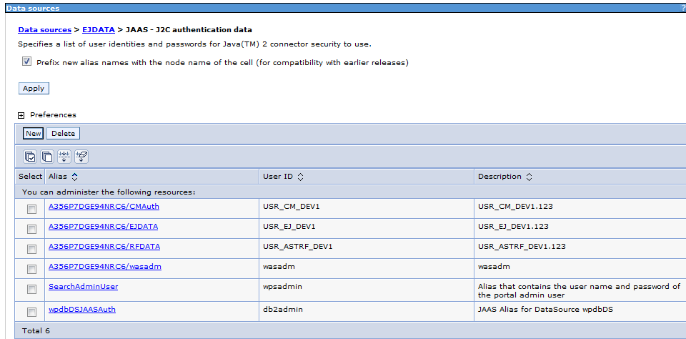

**Environment – Websphere Variables**

* Go to WAS Admin console -> Environment > WebSphere variables
* Select the “**WebSphere_Portal**” scope and click New.
* Enter **ORACLE_JDBC_DRIVER_PATH** for variable name
* Enter Value = **C:\oracle**

|  |  |
| --- | --- |
| **Name** | **Value** |
| **ORACLE_JDBC_DRIVER_PATH** | **C:\oracle** |

### Database Configuration

**Note : Copy ojdbc6.jar file at C:\oracle**



[**JDBC providers**](https://localhost:10032/ibm/console/navigatorCmd.do?forwardName=JDBCProvider.content.main&WSC=true) **> Oracle JDBC Driver (XA)**

#### **JDBC providers**

* Go to WAS Admin Console -> Resources -> JDBC -> JDBC providers
* Select the “**WebSphere_Portal**” scope and click New
* Select “Oracle” for “Database type”, “Oracle JDBC Driver” for “Provider type”, “XA data source” for “Implementation type” and “Oracle JDBC Driver (XA)” will be populated for “Name”. Click “Next”
* Class path and Directory location will be pre-populated. Ensure that the directory location is correct and click “Next”
* Click “Finish” and then “Save”

|  |  |  |
| --- | --- | --- |
| **Name** | **Class Path** | **Implementation Class name** |
| **Oracle JDBC Driver (XA)** | **${ORACLE_JDBC_DRIVER_PATH}/ojdbc6.jar** | **oracle.jdbc.xa.client.OracleXADataSource** |

**Resources - JDBC -** [**JDBC**](https://localhost:10032/ibm/console/com.ibm.ws.console.security.forwardCmd.do?forwardName=JAASAuthData.content.main) **Data Source**

#### **Data sources**

There are four data sources needs to be created for four databases.

1. EJData

* Go to WAS Admin Console -> Resources > JDBC > Data sources
* Select “**WebSphere_Portal**” for scope
* Click “New” and create EJ datasource

Data source name: **EJDATA**,

JNDI name: **jdbc/EJDATA**,

Select an existing JDBC provider: **Oracle JDBC Driver (XA)**,

URL: **jdbc:oracle:thin:@tkdp2datdbcc13n4-scan.p2g.netd.hk.hsbc:1521/dastrf01.hk.hsbc**

Data store helper class name: **Oracle10g data store helper**

Authentication alias for XA recovery: **<YOUR COMP. NAME>/EJDATA**

Component-managed authentication alias: **<YOUR COMP. NAME>/EJDATA**

Mapping-configuration alias: **(none)**

Container-managed authentication alias: **<YOUR COMP. NAME>/EJDATA**

* Verify the connection is successful by selecting “**EJDATA**” and then clicking on “Test Connection” button.

|  |  |  |
| --- | --- | --- |
| **Name** | **JNDI Name** | **URL\*** |
| **EJDATA** | **jdbc/EJDATA** | **jdbc:oracle:thin:@tkdp2datdbcc13n4-scan.p2g.netd.hk.hsbc:1521/dastrf01.hk.hsbc** |
| **RFDATA** | **jdbc/RFDATA** | **jdbc:oracle:thin:@tkdp2datdbcc13n4-scan.p2g.netd.hk.hsbc:1521/dastrf01.hk.hsbc** |

* Select “**WebSphere_Portal**” for scope
* Click “New” and create EJ datasource

Data source name: **RFDATA**,

JNDI name: **jdbc/RFDATA**,

Select an existing JDBC provider: **Oracle JDBC Driver (XA)**,

URL: **jdbc:oracle:thin:@tkdp2datdbcc13n4-scan.p2g.netd.hk.hsbc:1521/dastrf01.hk.hsbc**

Data store helper class name: **Oracle10g data store helper**

Authentication alias for XA recovery: **<YOUR COMP. NAME>/RFDATA**

Component-managed authentication alias: **<YOUR COMP. NAME>/RFDATA**

Mapping-configuration alias: **(none)**

Container-managed authentication alias: **<YOUR COMP. NAME>/RFDATA**

* Verify the connection is successful by selecting “**RFDATA**” and then clicking on “Test Connection” button.

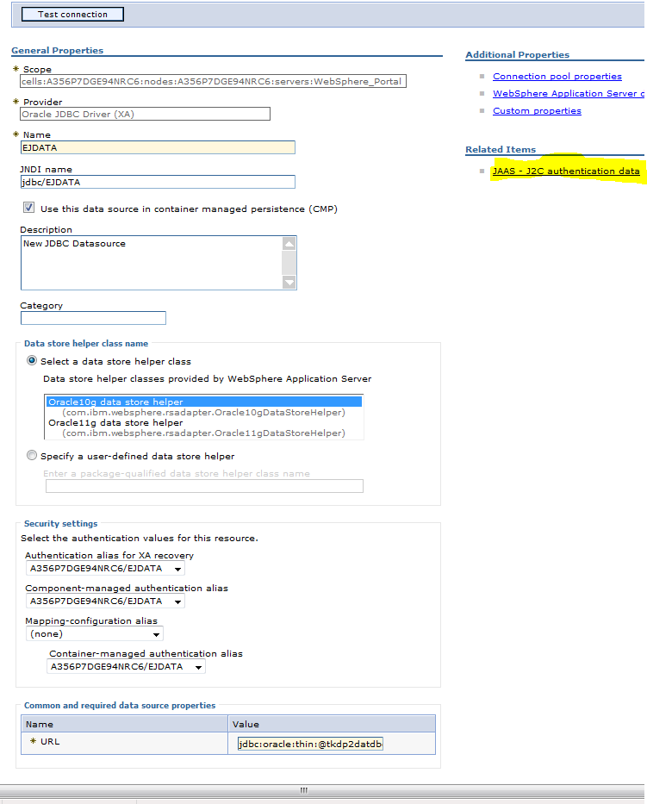

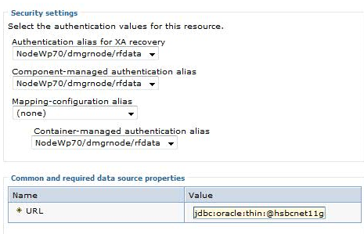

**Follow below Document for SSL, QCF & Queue configurations**



### Shared app JARs

There are few jars and xml files that need to be copied to portal shaped folder. There is a module named “group-staff-portal-config” which is responsible to collect the required configuration and jar files and zip them up into a file and install it in your local Maven repository. The zip can be found at C:\M2_Repository\com\hsbc\group\channels\staff\group-staff-portal-config\

Unzip this zip file to <WebSphere Portal Server>\Portal Server\Shared

Note: Don’t copy app and ext folder from somewhere else only extract. If copying don’t replace <WebSphere Portal Server>\Portal Server\Shared\shared.app.jar and <WebSphere Portal Server>\Portal Server\Shared\ext\shared.ext.jar these two jars must be specific to your web sphere which are generated at the time of installation.

### Installing Theme

Go to WAS Admin Console -> Applications -> Application Types -> WebSphere enterprise applications

* Click “Install” and install themes

Path to the new application: Local file system

**group-staff-themesskins-war-1.6.0.war**

C:\EvergreeningRepository\com\hsbc\group\channels\staff\ C:\EvergreeningRepository\com\hsbc\group\channels\staff\group-staff-themesskins-war \1.6.0

How do you want to install the application ?: Fast Path – Prompt only when additional information is required.

Apply “WebSphere_Portal” scope to selected module

Context root: /group-staff-themesskins-war

* Verify that group-staff-themesskins-war_war is running

### Login Portlet setup

* Edit web.xml at

<WebSphere Portal Server>\wp_profile\config\cells\[COMPUTERNAME]\applications\wps.ear\deployments\wps\wps.war\WEB-INF

Update the class name of the existing servlet filter Locale Filter.

Before

<filter>

<filter-name>Locale Filter</filter-name>

<filter-class>com.ibm.wps.engine.ExtendedLocaleFilter</filter-class>

</filter>

After

<filter>

<filter-name>Locale Filter</filter-name>

<filter-class> com.hsbc.group.chnlfrmwk.chnlfilters.portal.anonymous.ChanneldataPreProcessor

</filter-class>

</filter>

* Create pre-processor entry:

Go to WAS Admin Console -> Resources -> Resource environment -> Resource environment providers -> WP StateManagerService -> Custom Properties

Note: Please check for spaces. Spaces should not be there in value after comma.

Name: preprocessors

Value: com.ibm.wps.state.preprocessors.urlmapping.URLMappingPreProcessor,com.ibm.wps.resolver.friendly.preprocessors.FriendlyPreProcessor,com.ibm.wps.resolver.portal.ResolvedPreprocessor,com.ibm.wps.state.preprocessors.selection.StandardPortalSelectionImpl, com.ibm.wps.state.preprocessors.selection.FragmentSelectionImpl,com.ibm.wps.state.preprocessors.selection.ResourceSelectionImpl,com.ibm.wps.state.preprocessors.eclipse.ExtensionPreProcessor,com.ibm.wps.state.preprocessors.portlet.RequestParameterMerger, com.hsbc.group.chnlfrmwk.chnlfilters.portal.anonymous.ChanneldataPreProcessor

### LoginFilterImpl Resource Environment Provider Custom Properties

WAS Admin Console -> Resources -> Resource Environment -> Resource Environment Providers

Check Channel Filters User Guide documentation for more info.

| **Service Name** | **Property Name** | **Property Value** |
| --- | --- | --- |
| WP AuthenticationService | login.explicit.filterchain | **<Existing explicit login filter chain>,**com.hsbc.group.chnlfrmwk.chnlfilters.portal.logon.LoginFilterImpl |
| WP AuthenticationService | login.implicit.filterchain | **<Existing implicit login filter chain>,**com.hsbc.group.chnlfrmwk.chnlfilters.portal.logon.LoginFilterImpl |

### State Management

* Setup configuration directory:

Go to WAS Admin Console -> Environment > Naming > Name Space Binding and create new entry:

Binding type = String

Binding identifier = STATEMANAGEMENT_CONFIG_LOCATION

Name in name space = STATEMANAGEMENT_CONFIG_LOCATION

*String value = <WebSphere Portal Server>\PortalServer\shared\app\group\group\statemanagement

*Depends on local server install location

* Add preprocessor entry:

Go to WAS Admin Console -> Resources -> Resource environment -> Resource Environment Providers -> WP StateManagerService -> Custom Properties

Add this processor at the end of configured processors:

com.hsbc.group.statemanagement.enforcement.portal.StateManagementPreProcessor

**Portal Admin Console**

<https://localhost:10032/wps/portal/>

Go to Portal Admin Console -> Portlet Management -> Web Modules and install the following five war files:

**group-staff-navigation-portlet-1.6.0.war** / **Install the htsn-staff-navigation-portlet-1.4.0.war**

C:\EvergreeningRepository\com\hsbc\group\channels\staff\group-staff-navigation-portlet\1.6.0

**group-staff-datahelper-portlet-1.6.0**

C:\EvergreeningRepository\com\hsbc\group\channels\staff\group-staff-datahelper-portlet\1.6.0

**C:\workspace\sfe\hbusintegrationfs4\htsn-staff-buildaggregate>mvn -e clean install**

C:\EvergreeningRepository\com\hsbc\group\channels\staff\group-staff-datahelper-portlet\1.6.0

**group-foundation-war-2.0.2.war**

**C:\EvergreeningRepository\com\hsbc\group\channels\staff\htsn-staff-war\1.8.0-E2**

**htsn-staff-war-1.8.0-E2.war**

**htsn-esf-ca-app-content-portlet-1.6.0.war**

**htsn-staff-navigation-portlet-1.4.0.war**

**htsn-staff-contactbaradmin-war-1.6.0.war**

Download group-foundation-war-2.0.2 from <https://dsnexus.uk.hibm.hsbc:8082/nexus/index.html#nexus-search;quick~group-foundation-war>   
Go to Portal Admin Console -> Portlet Management -> Web Modules and install the above jar

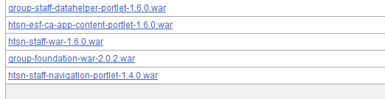

<https://dsnexus.uk.hibm.hsbc:8082/nexus/content/repositories/group.channels->**qa/com/hsbc/group/channels/staff/**

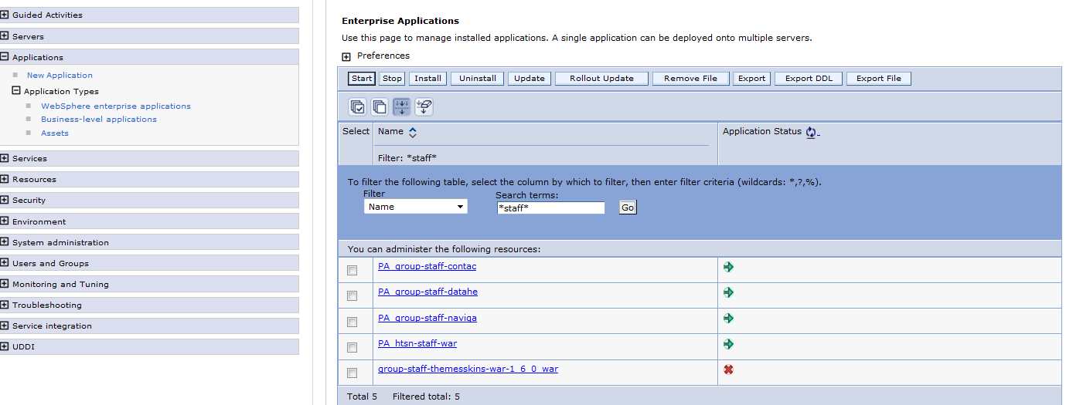

**Shared app Regionalization Changes for Portal setup**

Please find the link for regionalization changes provided by core for reference : [Customization And Regionalization](http://teams.global.hsbc/hts/gcs-staff/Staff%20Front%20End/Project%20Documents/Forms/AllItems.aspx?RootFolder=%2fhts%2fgcs%2dstaff%2fStaff%20Front%20End%2fProject%20Documents%2fStaff%20Front%20End%201%2e2%20Feature%20Pack%203%2fEngineering%2fDeployment%2fConfiguration%20and%20Regionalization&FolderCTID=0x012000A8925CEC7841574AAD2956EF585DF5D0)

And Do replace below given files in specified shared app location for HBUS SFE portal setup :

1. Path : **C:\swdtools\BM\WebSphere\PortalServer\shared\app\group\group\chnlfrmwk\chnlfilters**



2. We can create US_MMBI folder similar to other entities . replace below file at following location :

**C:\swdtools\BM\WebSphere\PortalServer\shared\app\group\group\chnlfrmwk\chnlfilters\US_MMBI**



3 .Path : **C:\swdtools\BM\WebSphere\PortalServer\shared\app\group\group\statemanagement**

Create similar folder **US\MMBI** as other entities . resources.xml is same as core file copy from any IN or AE folder



**Import XMLs – Restart on WAR installations**

Go to Portal Admin Console -> Portal Settings -> Import XML

**Import XMLS :**

 

**sssssss**

**Go to** <https://localhost:10032/wps/portal/>

**Get Home to the First place**

**Place thejsp in the below location:**

C:\SWDTOOLS\IBM\wps70was70\wp_profile\installedApps\NodeWp70\PA_htsn-staff-war.ear\-1.10.0-E3-SNAP.war\group\staff\datablocks



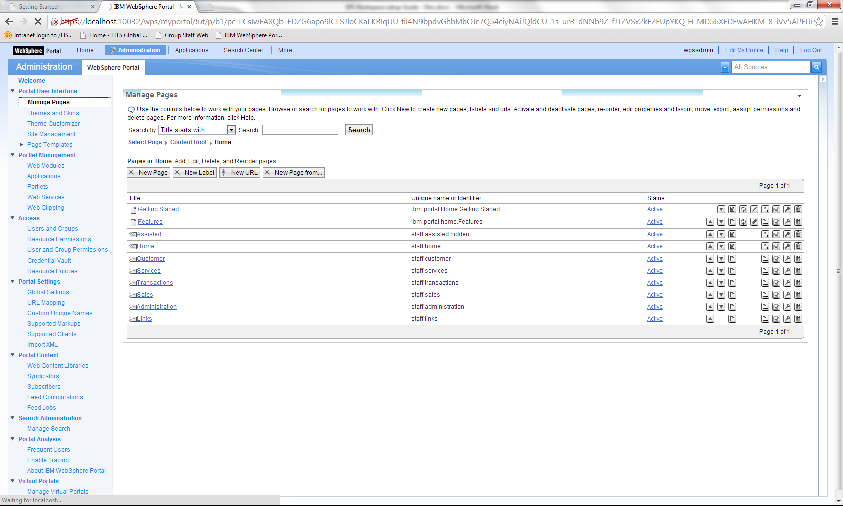

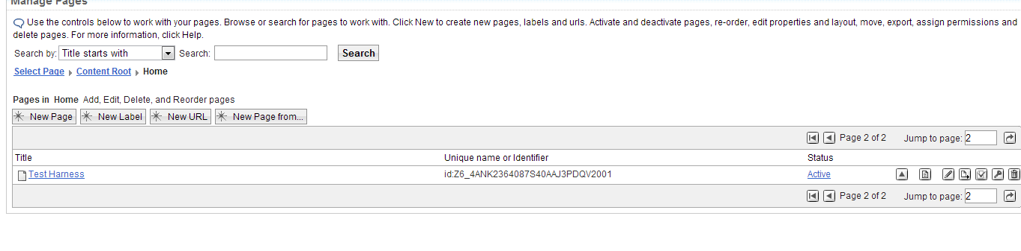

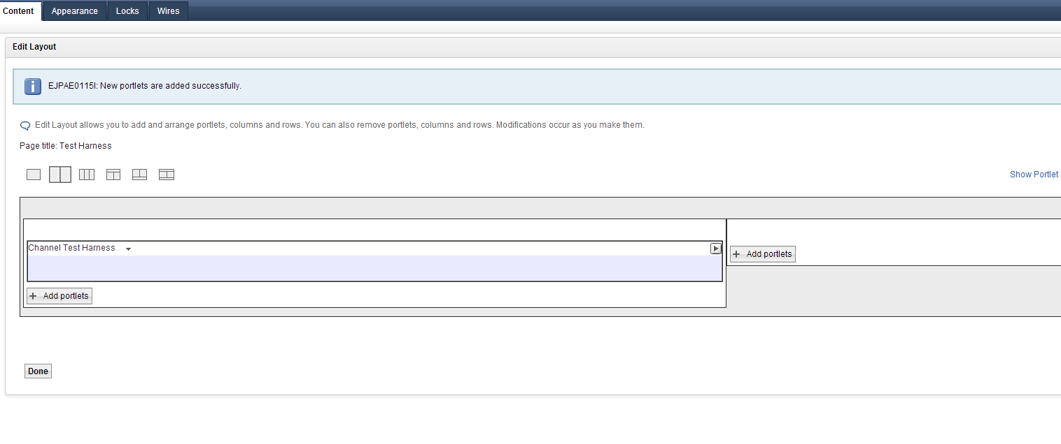

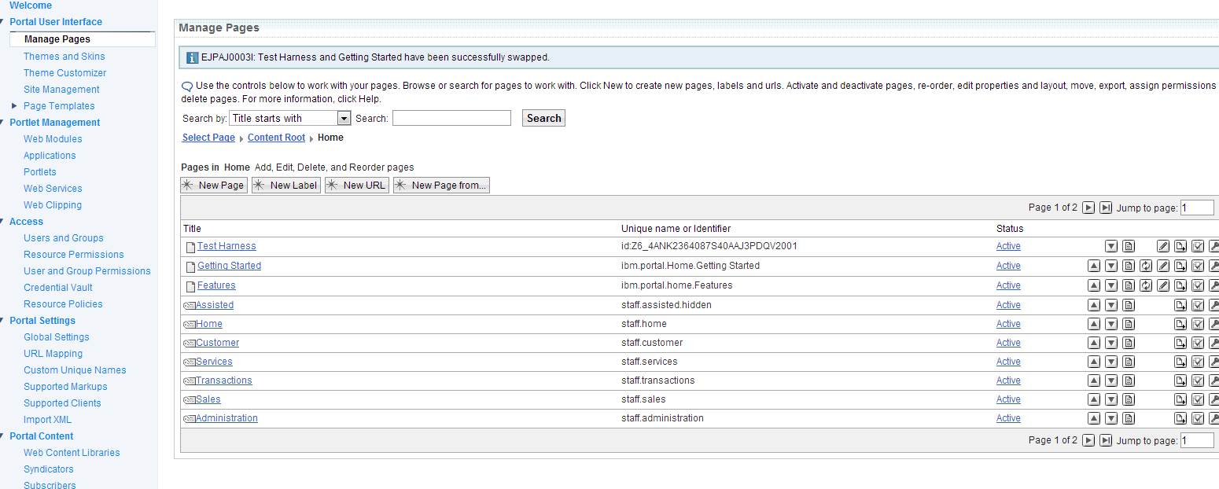

**Stop the themeskins war if getting error**

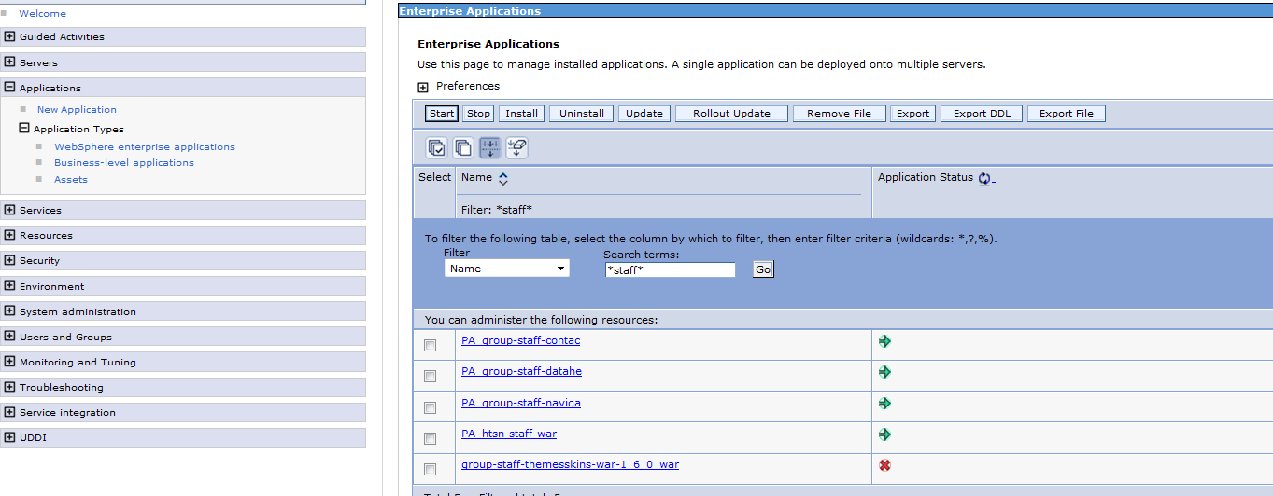

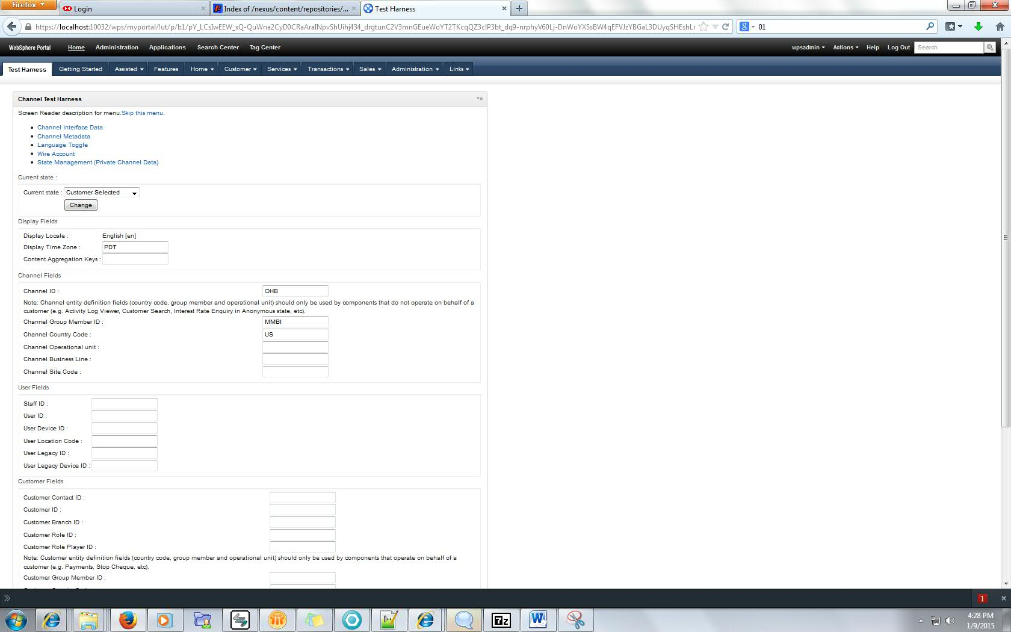

**Submit.**

**Goto Home -> Assisted -> Login**

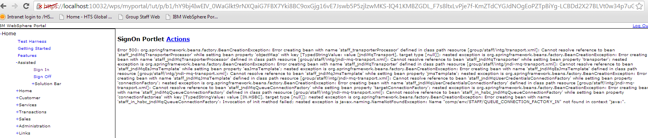

**Remove below code from /htsn-staff-war/target/war/work/group-staff-war-1.6.0-HBUS/WEB-INF/web.xml**

<resource-ref id=*"ResourceRef_1382506431858"*>

<description>

</description>

<res-ref-name>STAFF/QUEUE_CONNECTION_FACTORY_IN</res-ref-name>

<res-type>javax.jms.QueueConnectionFactory</res-type>

<res-auth>Container</res-auth>

<res-sharing-scope>Shareable</res-sharing-scope>

</resource-ref>

Solution: **Remove group-staff-intg jar from htsn-staff-war / lib**

/group-staff-intg/src/main/resources/group/staff/intg/jndi-mq-transport.xml

**C:\swdtools\BM\WebSphere\wp_profile\installedApps\A356P7DGE94NRC6\PA_htsn-staff-**

**war.ear\htsn-staff-war-1.war\htsn\staff\sessmgmt\signon\signOn.jsp**

Remove readonly=”true” for user ID

**Error in Customer Search:**

**Replace**

1. C:\swdtools\BM\WebSphere\wp_profile\installedApps\A356P7DGE94NRC6\PA_htsn-staff-war.ear\htsn-staff-war-1.war\htsn\staff\ao\customerInformation\custoverview\view\customer_overview.jsp

With 

1. C:\swdtools\BM\WebSphere\wp_profile\installedApps\A356P7DGE94NRC6\PA_htsn-staff-war.ear\htsn-staff-war-1.war\htsn\staff\ao\customerInformation\custoverview\datablocks\accountSummary.jsp

with

1. C:\swdtools\IBM\wps70was70\wp_profile\installedApps\NodeWp70\PA_htsn-staff-war.ear\htsn-staff-war-1.war\group\staff\datablocks\acctNumComposition.jsp

with

Error

java.lang.NoSuchMethodError: com/hsbc/group/staff/shared/custprofile/model/Account.setClassCode(Ljava/lang/String;)V at com.hsbc.group.staff.app.custprofile.impl.CustomerProfileServicePopulator.populateAccountInformation(CustomerProfileServicePopulator.java:1199) at com.hsbc.group.staff.app.custprofile.impl.CustomerProfileServicePopulator.createCustomerProfile(CustomerProfileServicePopulator.java:1067) at com.hsbc.group.staff.app.custprofile.impl.CustomerProfileServicePopulator.createCustomerProfiles(CustomerProfileServicePopulator.java:251)

at com.hsbc.group.staff.app.custprofile.impl.CustomerProfileServiceImpl.searchCustomers(CustomerProfileServiceImpl.java:415)

* **Put latest group-staff-shared-1.6.0-HBUS jar at C:\SWDTOOLS\IBM\wps70was70\PortalServer\shared\app**

**As group-staff-parent refers to group-staff-shared-1.6.0-HBUS**

|  |
| --- |
|  |
|  |

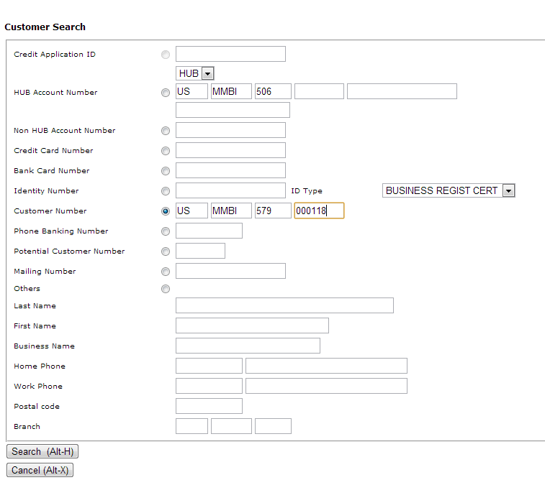

**HUB : USMMBI501000012066**

**Non HUB : USMMBI507000644001**

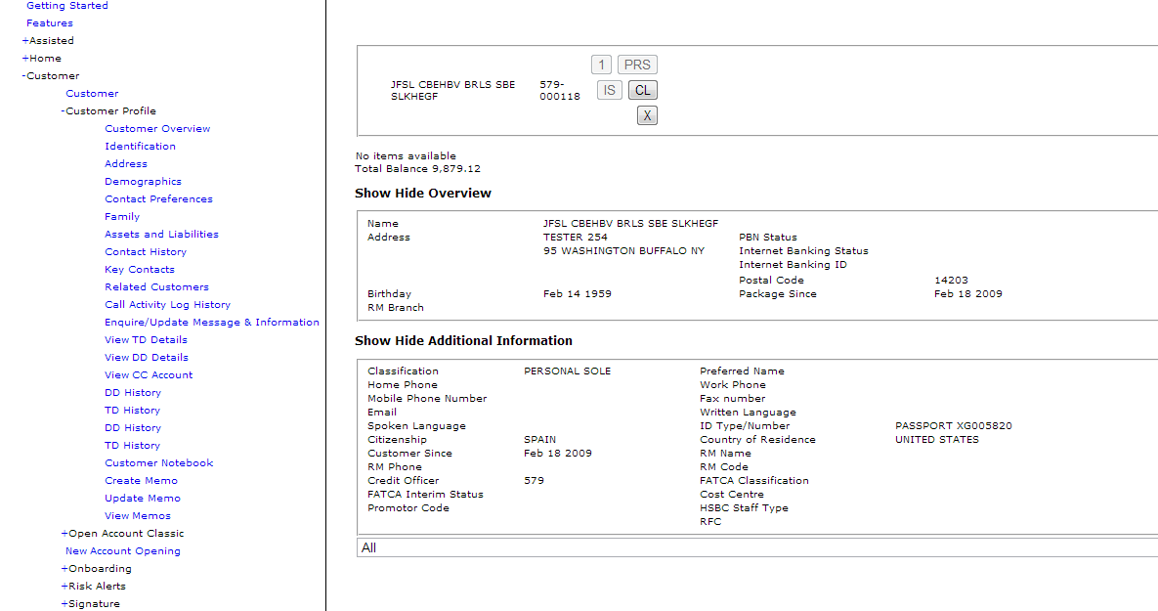

**Add Home Page**

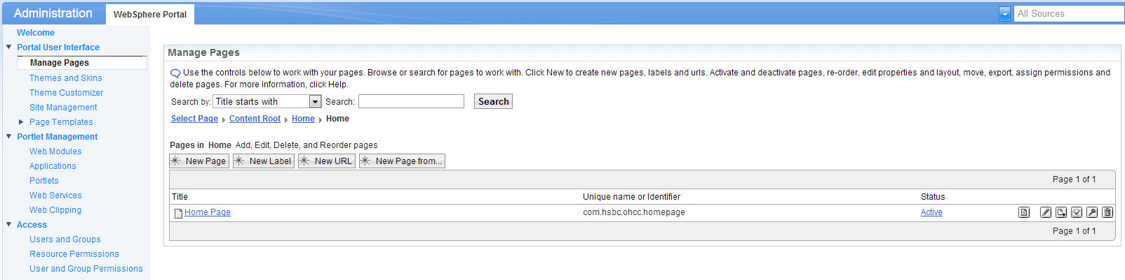

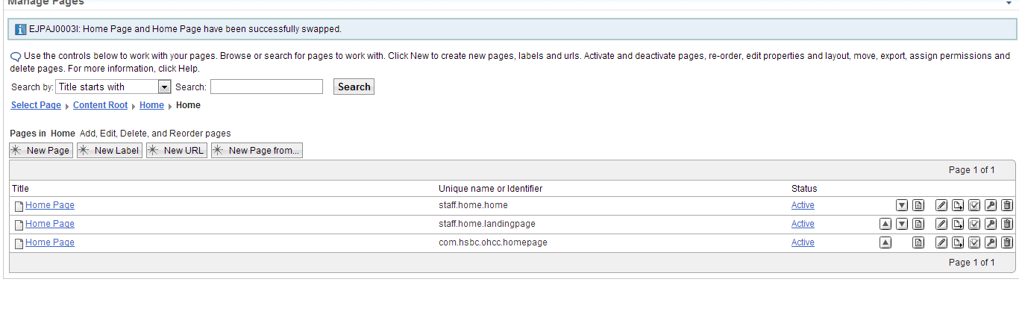

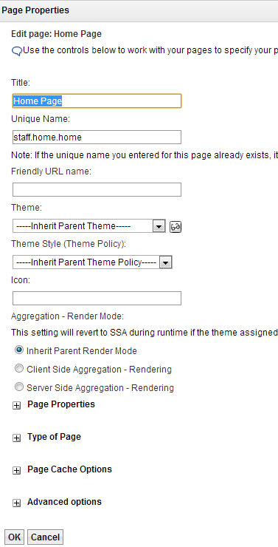



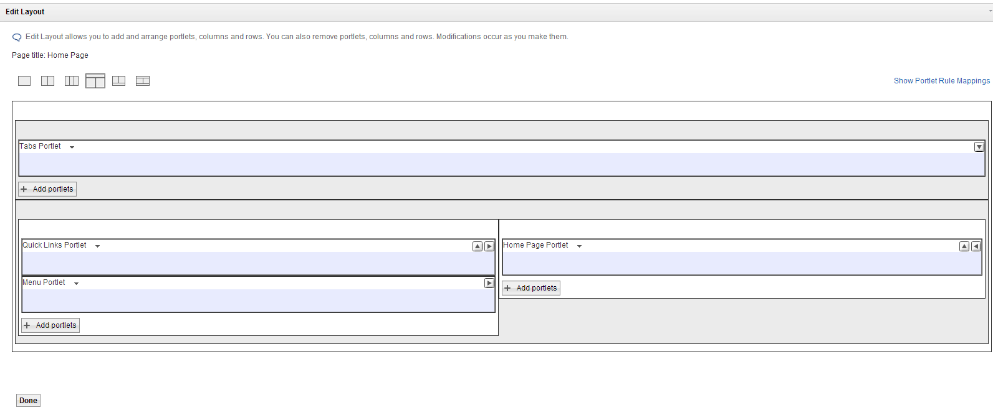



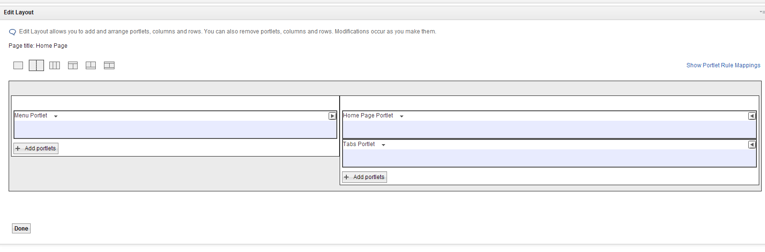



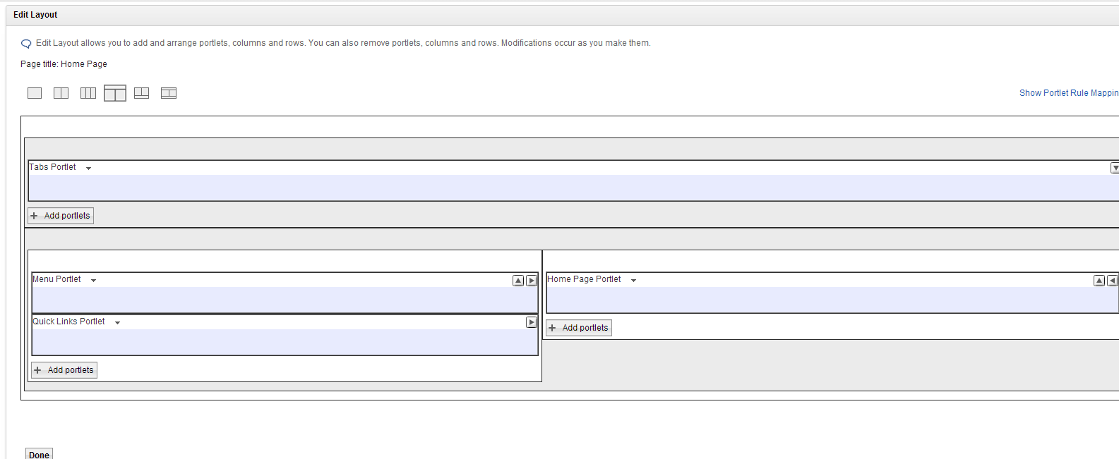

**Do configuration on** <http://localhost:10039/wps/portal>

Set Default Theme & Skin as below;

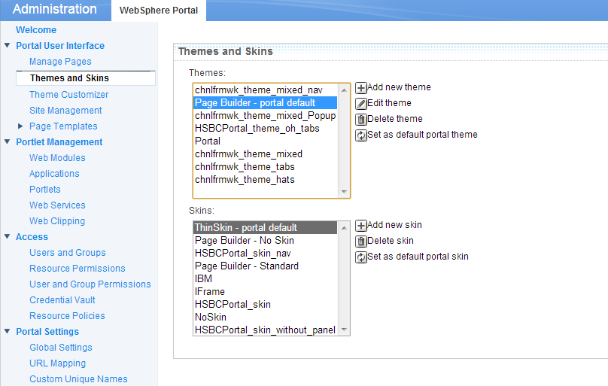

Edit chnlfrmwk_theme_mixed_nav

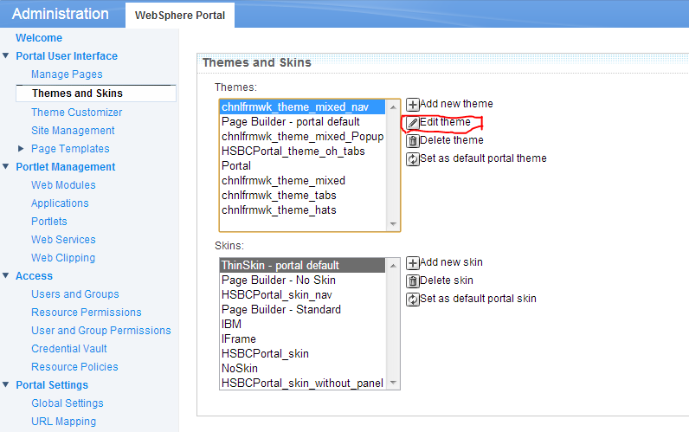

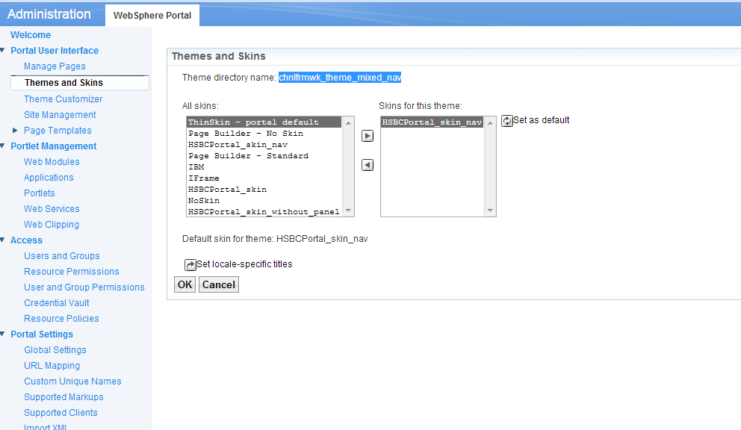

Edit page properties for Home page & set theme to Page Builder.

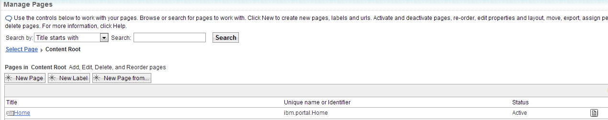

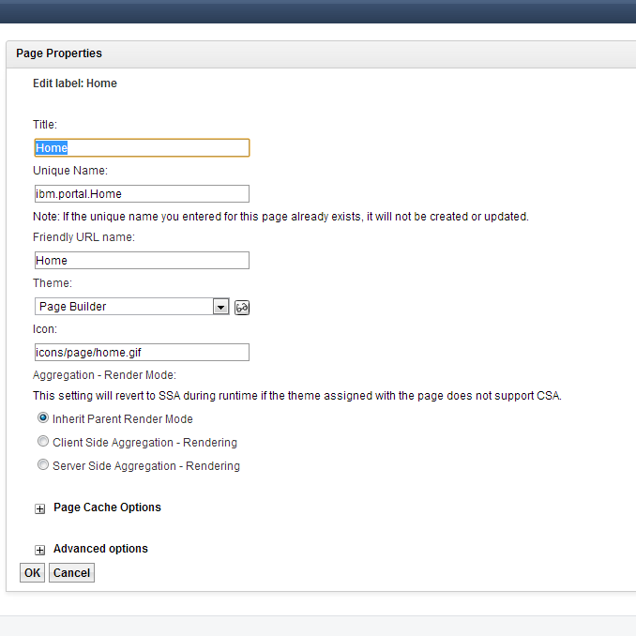

Edit page properties for Home

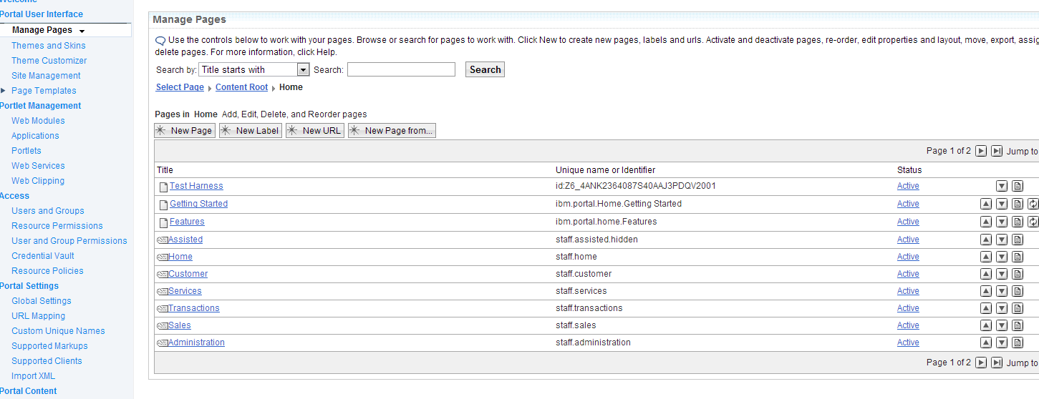

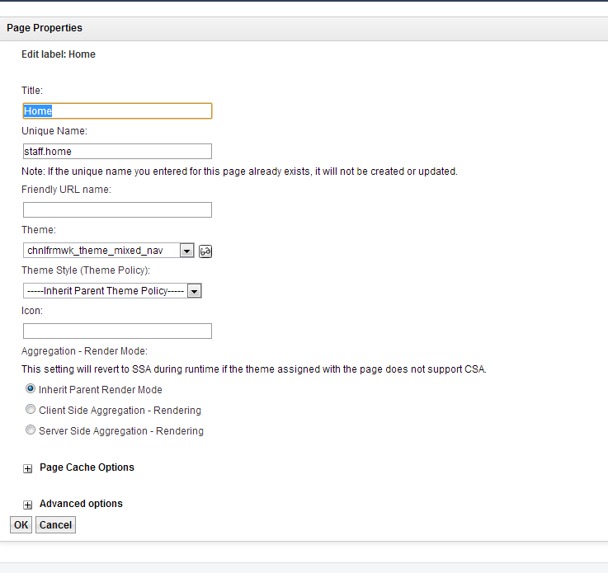

Add Tab & Menu portlet to Customer search.

Once done all the setup we can export the Home xml & use for other local setup



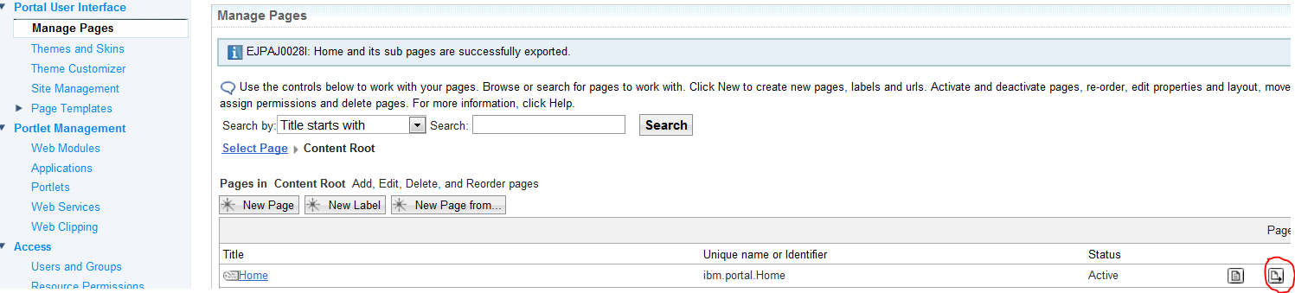

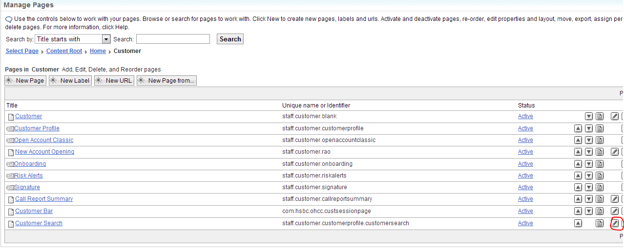

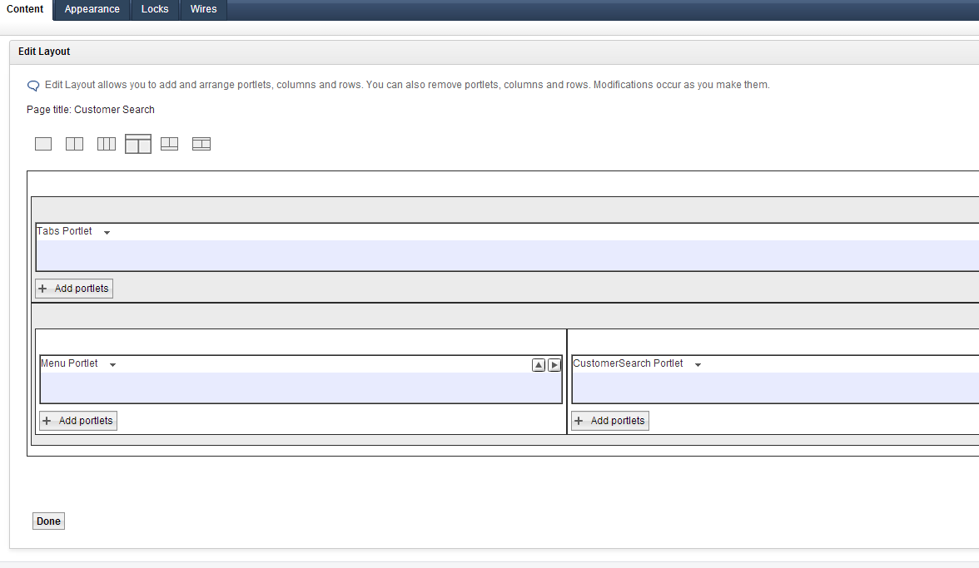

Also add the Tabs & Menu portlet for each page you want to use.

Start theme skin war from WAS console

HUB : USMMBI501000012066

Non HUB : USMMBI507000644001

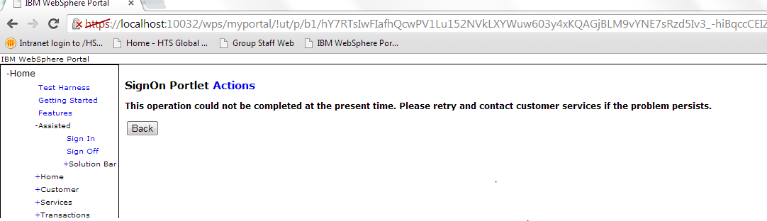

**FSA CUN - correct unique name for home page**

Common Errors :

|  |
| --- |
| at com.ibm.ws.util.ThreadPool$Worker.run(ThreadPool.java:1550) [6/24/15 11:56:23:066 IST] 00000050 SystemOut O userProfileMap{BE01=com.hsbc.group.staff.shared.userprofile.model.UserProfile@4c2a4c2a} [6/24/15 11:56:26:893 IST] 00000050 SystemOut O [Time:2015-06-24 11:56:26,893][Level:ERROR]java.lang.NoSuchMethodError: com/hsbc/group/staff/shared/custprofile/model/Account.setClassCode(Ljava/lang/String;)V at com.hsbc.group.staff.app.custprofile.impl.CustomerProfileServicePopulator.populateAccountInformation(CustomerProfileServicePopulator.java:1199) at com.hsbc.group.staff.app.custprofile.impl.CustomerProfileServicePopulator.createCustomerProfile(CustomerProfileServicePopulator.java:1067) at com.hsbc.group.staff.app.custprofile.impl.CustomerProfileServicePopulator.createCustomerProfiles(CustomerProfileServicePopulator.java:251) at com.hsbc.group.staff.app.custprofile.impl.CustomerProfileServiceImpl.searchCustomers(CustomerProfileServiceImpl.java:415) at com.hsbc.group.staff.sessmgmt.pres.customersearch.processors.CustomerSearchRequestProcessor.process(CustomerSearchRequestProcessor.java:177) at com.hsbc.esf.requestprocessing.eventmapping.impl.ProcessorEventMappingAction.execute(ProcessorEventMappingAction.java:99) at com.hsbc.esf.requestprocessing.eventmapping.impl.DefaultEventMapping.process(DefaultEventMapping.java:213) |

**Solution :**

**Copy latest jars for group-staff-shared-1.6.0-HBUS.jar & group-staff-svc-1.6.0.jar**

**At C:\swdtools\BM\WebSphere\PortalServer\shared\app**

**Error**

Caused by: com.ibm.mq.MQException: JMSCMQ0001: WebSphere MQ call failed with compcode '2' ('MQCC_FAILED') reason '2035' ('MQRC_NOT_AUTHORIZED').

at com.ibm.msg.client.wmq.common.internal.Reason.createException(Reason.java:223)

... 202 more

org.springframework.jms.JmsSecurityException: JMSWMQ2013: The security authentication was not valid that was supplied for QueueManager '' with connection mode 'Client' and host name '130.45.29.205(15340)'.; nested exception is com.ibm.msg.client.jms.DetailedJMSSecurityException: JMSWMQ2013: The security authentication was not valid that was supplied for QueueManager '' with connection mode 'Client' and host name '130.45.29.205(15340)'. Please check if the supplied username and password are correct on the QueueManager you are connecting to; nested exception is com.ibm.mq.MQException: JMSCMQ0001: WebSphere MQ call failed with compcode '2' ('MQCC_FAILED') reason '2035' ('MQRC_NOT_AUTHORIZED').